Manual Instruction for promo code

Activate the promo code generator plugin in word press admin installed plugin.



Click on the **Active** option to activate the plugin.

Admin side:

Admin generates the promo code at admin side, while generating the promo code admin will set commission, discount and free shipping option, after entering valid values click the **Generates code** button and gets a conformation about successful promo code generated.

To generate a new promo code selects the **Promo code Generator** option from promo code generator plugin’s sub menu option.

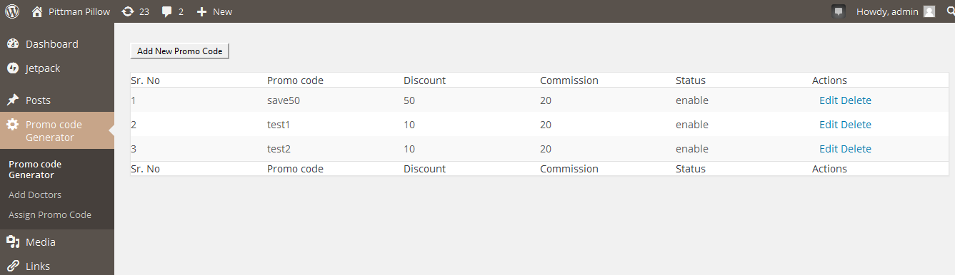

After selecting the promo code generator option, there is **Add New Promo Code** button at left top

After clicking on **Add New Promo code button** .A new page will open.

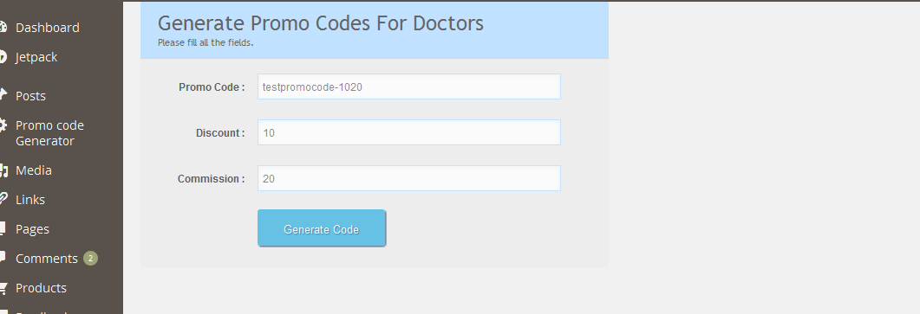

Here Admin have to enter Promo code name, discount and commission.

Admin can enter value from 0 to 99 in discount and commission filled.

In **promo code name** filled Admin can enter whatever wants but in discount and commission filled admin can only enter integer values.

E.g.

Promo code name is: testpromocode-1020

Discount value: 10

Commission value: 20

After entering the valid values click on **Generate code** button. Then admin will get a message that promo code generated successfully. After that admin will redirected to list of all promo code generated.

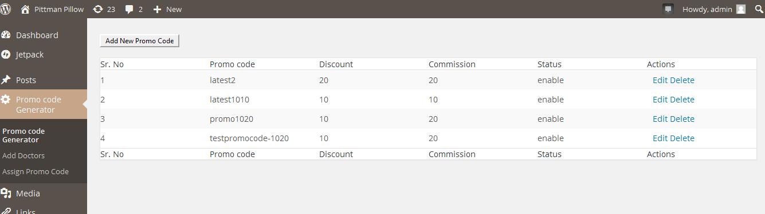

**If promo code generated already with same name, then admin will get alert of promo code already exist.**

Here **testpromocode-1020** already generated.

If admin try to generate same **testpromocode-1020 Promo code** again then **promo code already generated** will show on the admin window. Like

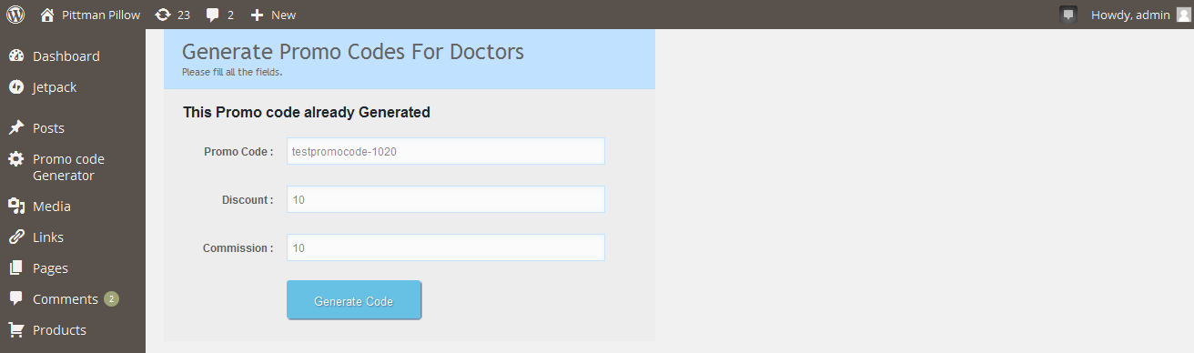

**How the admin can edit, delete a promo code.**

When admin click on Promo code Generator (plugin sub-menu option), then list of all promo code generated will be there.

In the table under **Actions** filled there is **Edit Delete** option.

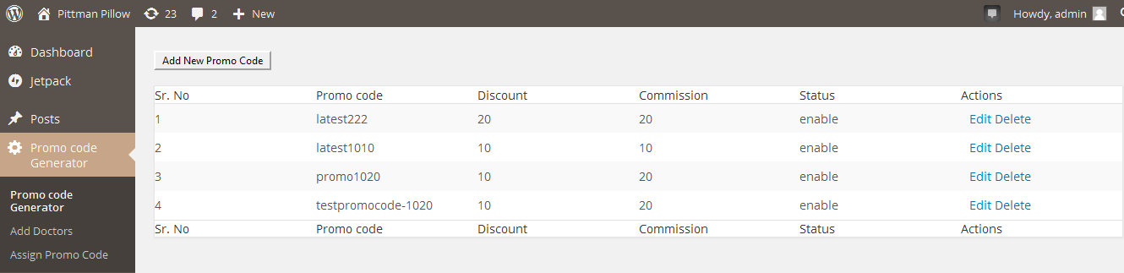

**Edit section:**

Admin can **edit** the promo code any time.

By clicking on **edit** option admin can change the value of commission, discount, enable, disable a promo code.

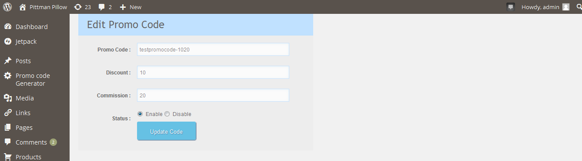

Now change the commission and discount value and status.

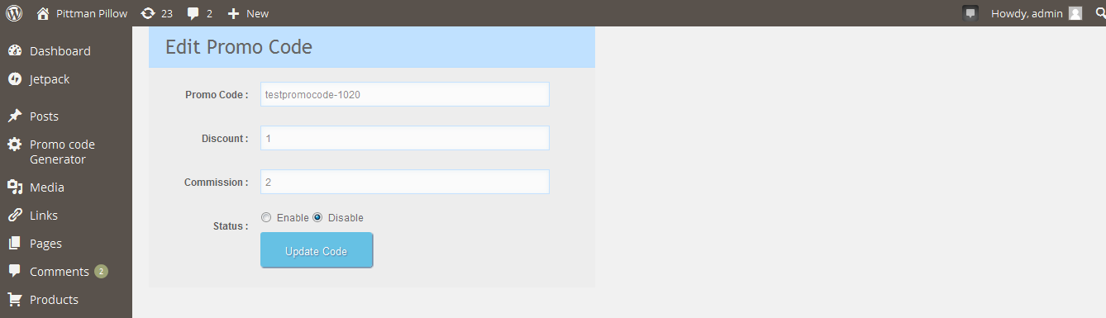

In edit section for enable/ disable a promo code there are two radio buttons, select the desire radio button and click the **update code** button. After clicking on the **update code** button updated promo code will be displayed in the all promo code list with changed values and status.

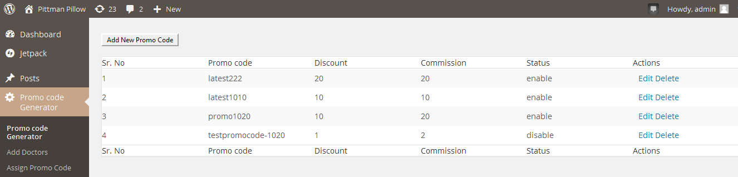

When admin make a promo code **disable** then that promo code will not work on <http://pittmanpillow.com/products-page/> . By disable a promo code admin will expire a promo code.

When user tries to use a disable promo code to buy product, in this case **invalid Promo Code** will be show to user.



**Delete:**

By clicking on delete option admin can permanently delete that particular promo code.

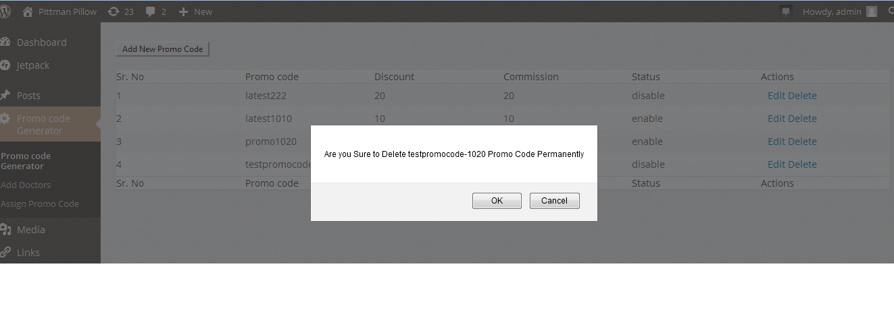

Once the promo code deleted that promo code will not work at <http://pittmanpillow.com/products-page/> to buy product.

Add Doctor/Professional

Admin can add the doctor/ professional here. Before assigning the promo code to doctor admin have to add that doctor by entering name of doctor and email.

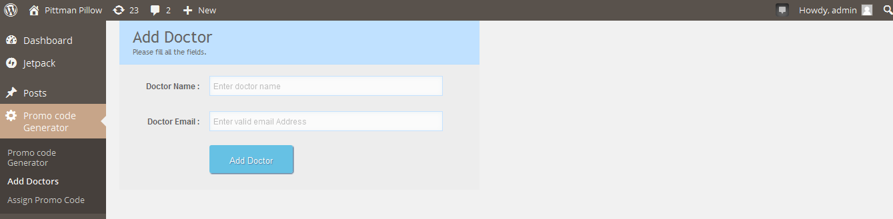

Once the doctor added successfully, then admin can assign a promo code to doctor.

**Assign Promo Code**

**Once the promo code generated and professional added successfully, then admin can assign promo code to professional.**

Admin will assign only one promo code to one doctor And one promo code to one professional only means one promo code belongs to one professional.

**How to assign promo code to professional**

To assign promo code to professional selects the **Assign Promo Code** option from plugin sub menu. On selecting the **Assign Promo Code** option, page will load on admin dashboard.

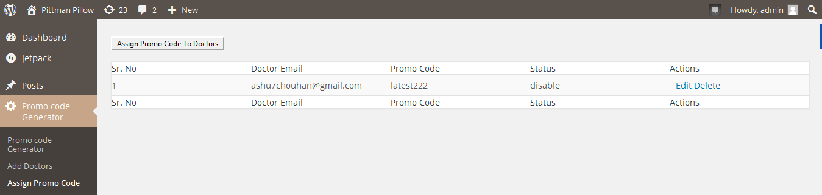

On the left top side there is a button **Assign promo code to professional**, click on this button a page will open.

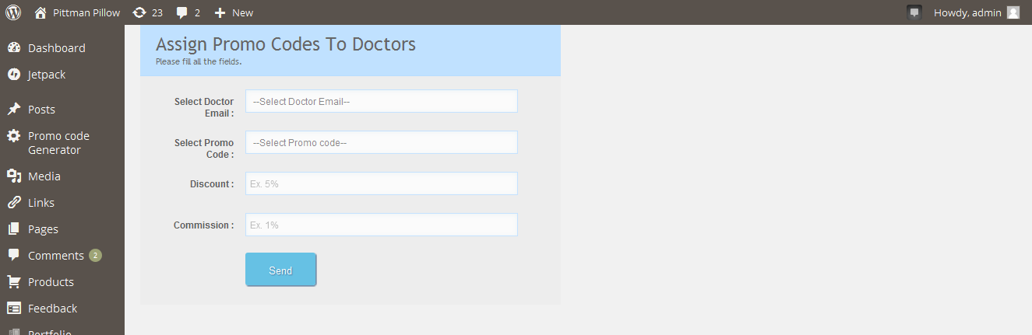

In this page there are four filed:

**Select doctor email:** Here is a drop down of all added doctor, admin have to select the email id to whom admin want to assign the promo code.

**Select Promo code**: Here is drop down of all unassigned promo code. Admin can select the desired promo code which he wants to assign to professional. When select the desired promo code discount and commission and shipping value attached with that promo code will automatically come in the discount, commission filled.

### If all promo code assigned to professional, then All Promo Codes Assigned, Please Generate New One to Assign will be shown to admin .

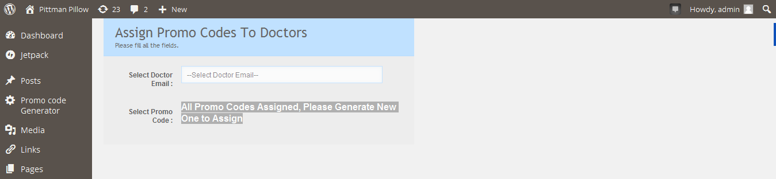

### Then admin first have to generates a new promo code first from generate promo code first and then admin can select the promo code to assign to professional.

**Discount:** This filled show how much discount customer will get on product in % .

**Commission:** This filled show how much commission that professional will earn in %.

When admin click on **send** button, email will be send to professional email id.

In this email all information regarding promo code will be there like promo code, discount, commission and free shipping etc.

Professional get the promo code by mail, now professional distribute the assigned promo code to their patient/customers.

**How to apply promo code on** [**http://pittmanpillow.com/products-page/**](http://pittmanpillow.com/products-page/) **to buy product**

When patient/customer gets the promo code, they can use promo code to buy product from <http://pittmanpillow.com/products-page/> .

To buy product customer/patient will click the **buy now** button.

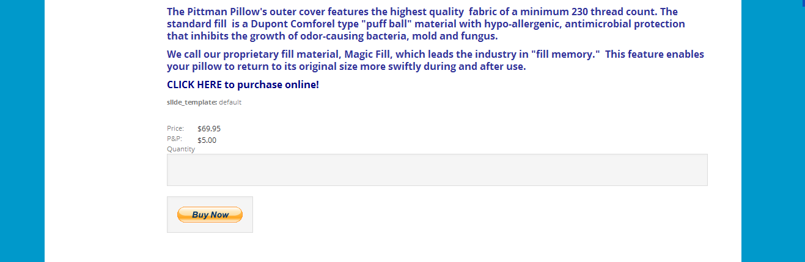

If a user visit <http://pittmanpillow.com> first time then user first have to register first.

When click on buy now button a pop up will appears for login/register.



If customer is not registered already, then customer needs to register first and then login.

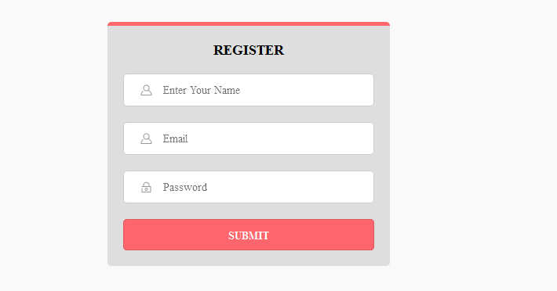

If customer is already registered then customer will login by entering their email and password.

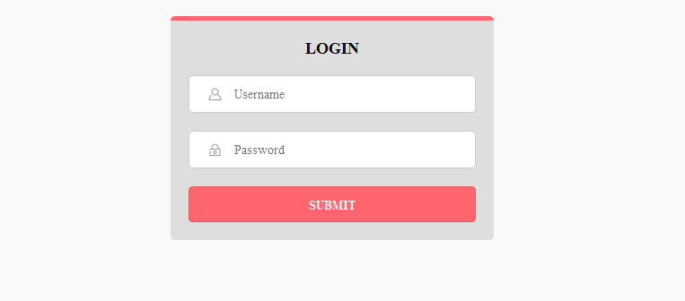

When successfully login, pop up will display to enter the promo code.

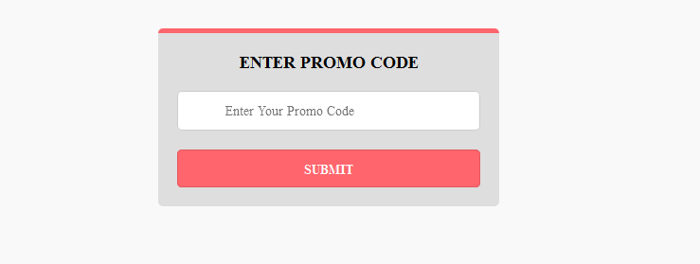Customer will enter the promo code here and click the submit button.

Getting free shipping message will be shown to customer. If there is any discount attached with promo code then discount will be applied on customer’s purchases and customer will be redirected on PayPal page for make payment.

When customer pays successfully, then customer/patient will not use that promo again. Mean one promo code for one time use for one customer.

When customer makes the **successfully payment** only then professional will **earn commission.**

**How the commission is added to professional account and admin can send details about the commission earns by professional on different order any time:**

From the used promo code we can identify to whom that promo code was assigned, because one promo code was assigned to one professional only and add commission earn by professional to that particular professional account.

By doing so it’s easy for admin to view how much commission earn by a professional.

By viewing the commission earns by professional admin can easily pay to professional.

Later I will also set the get print out option for particular professional account detail.so that when you send the check to professional admin can also send detail to professional about how professional have earned commission from different orders made by their patient/customers .

Once the commission part completed then do work on shipping option.